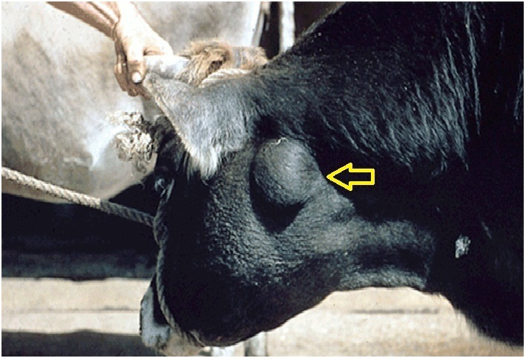

**Organ: L.N.**

**Lesion:** enlarged retropharyngeal lymph node.

**Cause:** *Actinobacillus ligniersi* G-ve bacteria

**Diagnosis:** Actinobacillosis

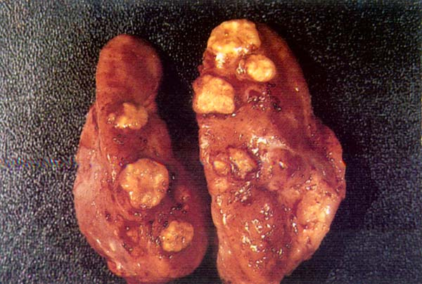

**Organ:** L.N.

**Lesion:** Multifocal, well demarcated yellow lesions in the retropharyngeal lymph node of a bovine animal.

**Cause:** *Actinobacillus ligniersi*

**Diagnosis:** Actinobacillosis

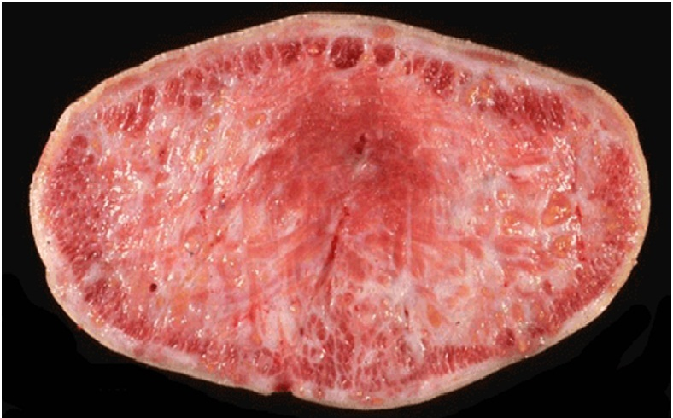

**Organ: Tongue**

**Lesion:** Cross section in bovine tongue. In chronic cases there is fibrous connective tissue proliferation replaced most of tongue muscle and becomes hard therefore it is called “wooden tongue”

**Cause:** *Actinobacillus ligniersi*

**Diagnosis:** Actinobacillosis

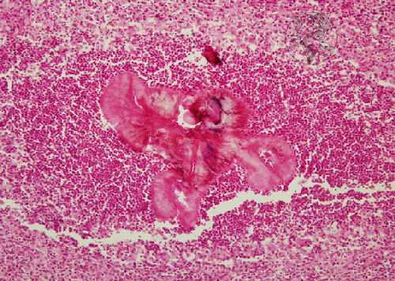

**Organ: L.N.**

**Lesion:** Actinobacillosis granuloma consists of eosinophilic central area, called sulfur granule, (formed by the pathogen & immune complexes synthesized as a response to the infection) enclosed in a neutrophilic cellular area. Peripherally, mononuclear cells infiltrate with F.C.T. (H&E, 100x).

**Etiology:** *Actinobacillus ligniersi*

**Diagnosis:** *Actinobacillosis*

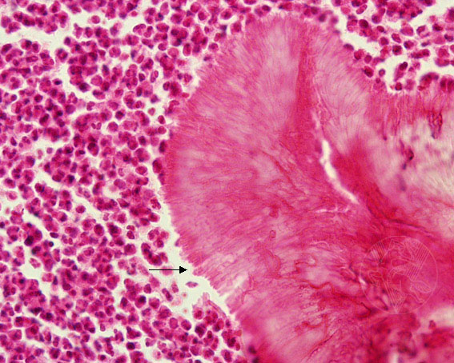

**Organ: L.N.**

**Lesion:** radiated structures arranged in palisade, called clubs, form the periphery of the sulfur granule. These structures are surrounded by neutrophils (H&E, 400X).

**Cause:** *Actinobacillus ligniersi*

**Diagnosis:** Actinobacillosis

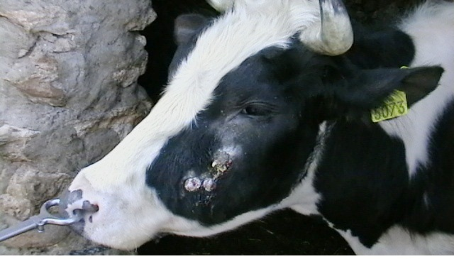

**Organ: Head of cow**

**Lesion:** Large mass in the lateral aspect of the lower jaw at the level of the central molar teeth.

**Etiology:** *Actinomyces bovis*

**Diagnosis:**  Actinomycosis (Lumpy Jaw)

**Organ: Head of bull**

**Lesion:** 2 month old lesion, characterized by granulomatous and suppurative abscess in the upper jaw (maxilla).

**Etiology:** *Actinomyces bovis*

**Diagnosis:**  Actinomycosis (Lumpy Jaw)

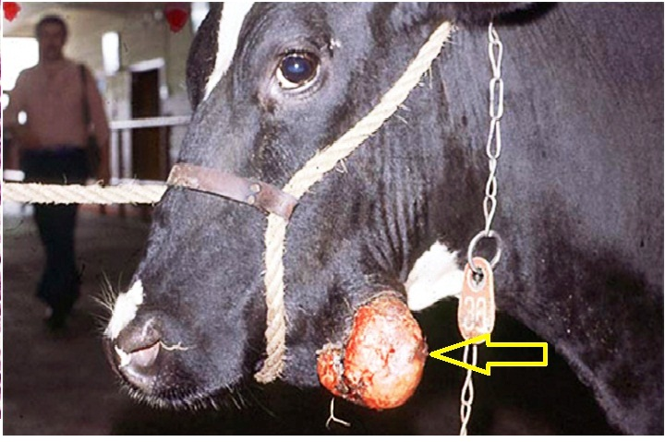

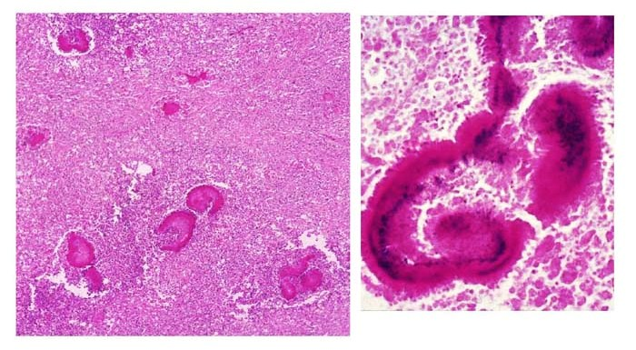

**Organ: hard tissue**

**Lesion:** left (H&Estain) right (Gram stain): *A. bovis* produce large, horse shoe shape sulfur granule. Gram positive thread like bacteria are seen just beneath the clubs.

**Etiology:** *Actinomyces bovis*

**Diagnosis:** Actinomycosis (Lumpy Jaw)

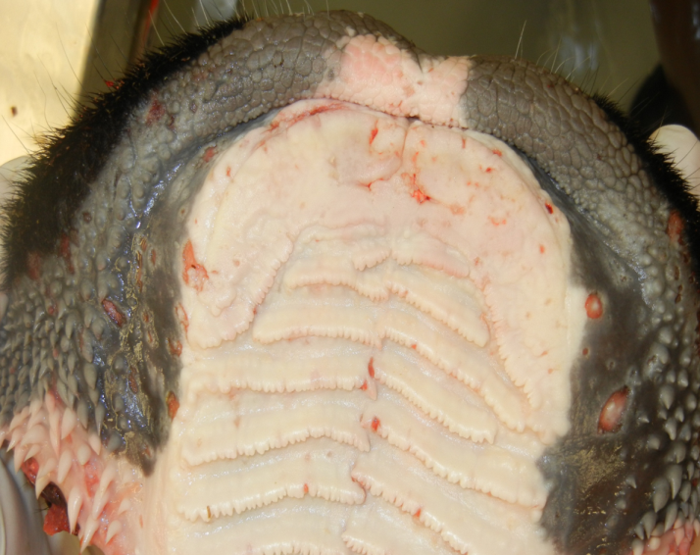

**Organ: Hard plate**

**Lesion:**  multiple area of erosion lead to ulcers

**Etiology:** Pestivirus family togaviridae

**Diagnosis:**  bovine viral diarrhea



**Organ: Tongue**

**Lesion:** multiple areas of erosions and ulcers on the ventral surface and tip of the tongue.

**Etiology:** Pestivirus family togaviridae

**Diagnosis:**  bovine viral diarrhea

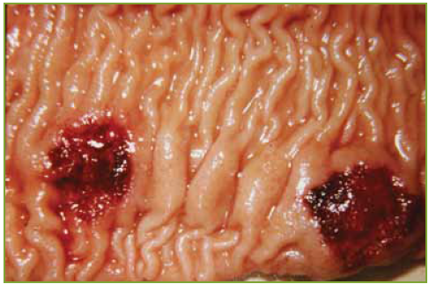

**Organ: Intestine**

**Lesion:**  the affected payer’s batches are hemorrhagic, necrotic and ulcerated.

**Etiology:** Pestivirus family togaviridae

**Diagnosis:**  bovine viral diarrhea

**Organ:** Brain

**Lesion:** Cerebral hypoplasia shown in BVD compared with a normal cerebellum on the left

**Etiology:** Pestivirus family togaviridae

**Diagnosis:**  bovine viral diarrhea

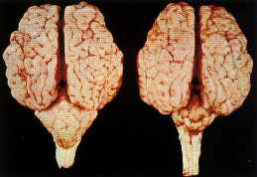

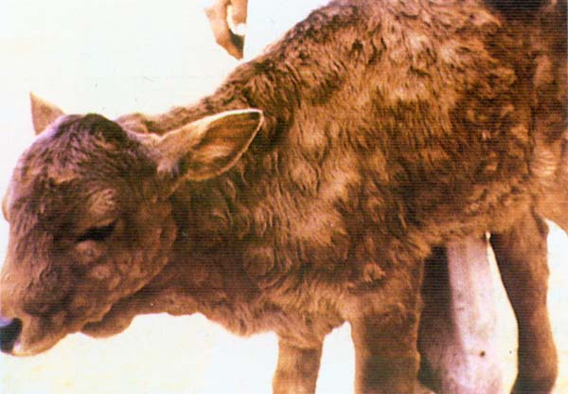

**Calve**

**Lesion:** Various sized cutaneous nodules in severe case.

**Etiology:** Neethling pox virus, genus of poxviruses.

**Diagnosis:** Lumpy skin disease.

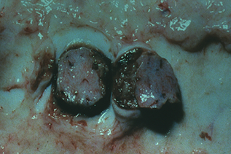

**Organ: lymph node**

**Lesion:**.enlargment of lymph node, which appear edematous and necrotic.

**Etiology:** Neethling pox virus, genus of poxviruses.

**Diagnosis:** Lumpy skin disease.

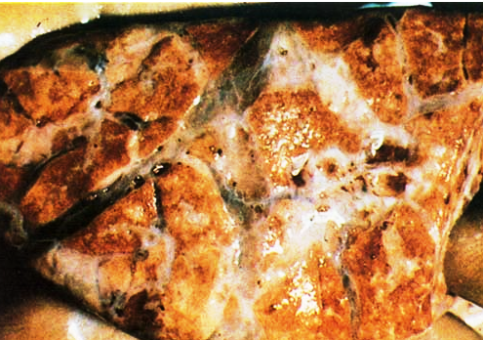

**Organ:** Lung

**Lesion:** Cut surface of the nodules in parenchyma of lung appear as black necrotic areas also there is areas of atelectasis and interlobular edema

**Etiology:** Neethling pox virus, genus of poxviruses.

**Diagnosis:** Lumpy skin disease.